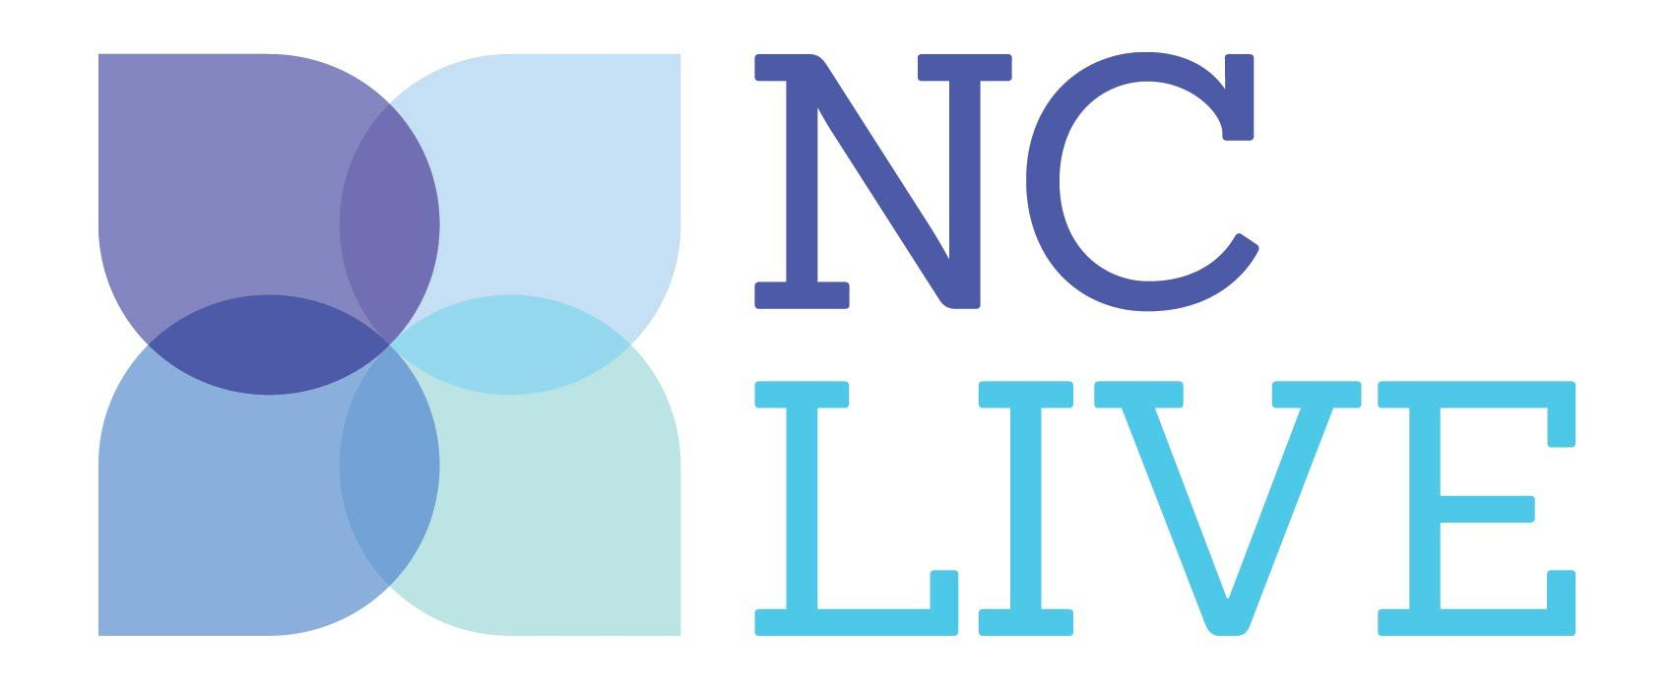
Media Contact:
Name
Title
Library Name
Address
City, State, Zip
Phone
Email

FOR IMMEDIATE RELEASE
[Insert Date]

NC LIVE Helps [LIBRARY NAME] Patrons Succeed, 24 Hours a Day
[CITY], NC – [Insert a few sentences of your library’s patron success story or stories here, for example “An entrepreneur in Stokesdale has a utility patent granted, while a small business owner in Mooresville opens her first retail store,” or “Virginia Soles, 43, is starting her last semester with a 3.9 GPA..” ] Each credits part of their success to [INSERT LIBRARY NAME], and the tools and information they can access online, anytime, for free through NC LIVE.
These stories and other have been collected in NC LIVE Impact, a new digital library awareness campaign showcasing how residents use North Carolina’s digital library resources to get the information they need to meet their goals---twenty-four hours a day, from any device.
The state’s 201 public and academic libraries have collectively funded the NC LIVE online library since 1998 to ensure every resident has access to quality research materials, streaming videos, and ebooks. The digital library also includes tools for everything from competitive business analysis and market research to academic and professional test prep, genealogy research, and language learning.
All of these resources are costly, but licensing and managing them collectively saves libraries time and money. “NC LIVE spends $3.4 million a year to provide access to content that would cost our member libraries $23 million to acquire on their own. This partnership creates tremendous value for libraries of all types and sizes,” notes NC LIVE Executive Director Rob Ross.
Library Director [INSERT NAME] stated, [insert a quote here such as “NC LIVE gives us access to a core collection of digital resources accessible to our patrons anytime, anywhere. It frees us to focus our budget on the needs that are specific to our community.”]
The Impact campaign will run through the end of March 2017, during which time NC LIVE and member libraries will promote digital resources and highlight how they have helped North Carolinians achieve their goals. The campaign includes social media messaging and public radio underwriting to spread the world about NC’s own digital library. Individuals can learn more and donate to the NC LIVE Foundation at www.nclive.org/impact.
About [Insert Library Name]
[Insert library boilerplate.]

About NC LIVE
NC LIVE is a statewide library consortium that provides shared digital content and services to North Carolina’s community colleges, public libraries, the UNC System, and NC Independent Colleges and Universities. Patrons of NC LIVE’s 200 member libraries may access eBooks, magazines, newspapers, journals, streaming videos, and more online via library websites, and through www.nclive.org.

About The NC LIVE Foundation
The NC LIVE Foundation strengthens the mission and activities of the NC LIVE program through the promotion and use of digital content and services that support education, enhance economic development, and improve the quality of life in communities across North Carolina. www.nclivefoundation.org

###

